**Topics: Descriptive Statistics and Probability**

1. Look at the data given below. Plot the data, find the outliers and find out $μ, σ, σ^{2}$

|  |  |
| --- | --- |
| **Name of company** | **Measure X** |
| Allied Signal | 24.23% |
| Bankers Trust | 25.53% |
| General Mills | 25.41% |
| ITT Industries | 24.14% |
| J.P.Morgan & Co. | 29.62% |
| Lehman Brothers | 28.25% |
| Marriott | 25.81% |
| MCI | 24.39% |
| Merrill Lynch | 40.26% |
| Microsoft | 32.95% |
| Morgan Stanley | 91.36% |
| Sun Microsystems | 25.99% |
| Travelers | 39.42% |
| US Airways | 26.71% |
| Warner-Lambert | 35.00% |

Solu:

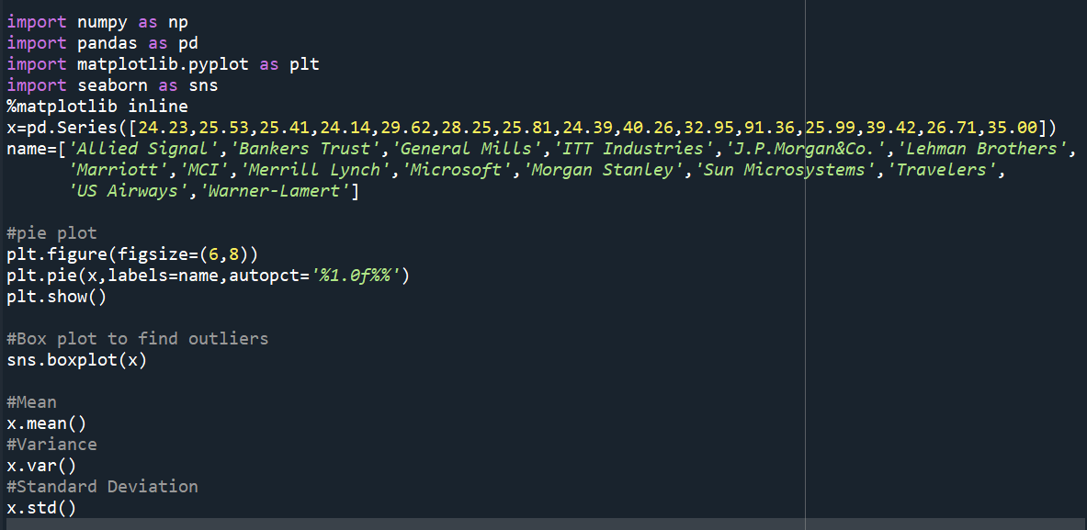

Output:

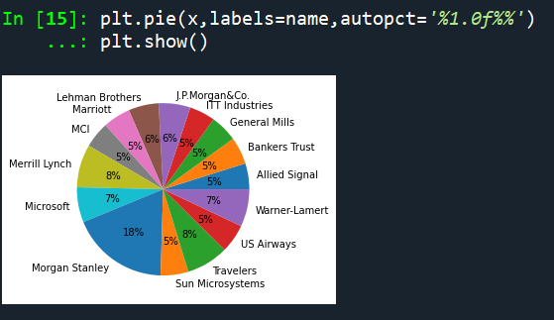

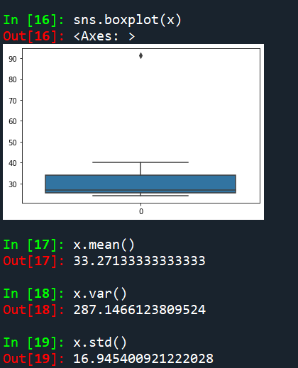

For the given data the outlier is 90

Mean=33.271

Variance=287.14

Standard Deviation:16.945

2.

Answer the following three questions based on the box-plot above.

1. What is inter-quartile range of this dataset? (please approximate the numbers) In one line, explain what this value implies.

Ans:From above Diagram,

Approximately Q1(first Quantile Range) =5, Median(Second Quantile Range)=7,

Q3(Third Quantile Range )=12

The Formula for calculating Inter quartile Range :

IQR=Q3-Q1

= 12-5

=7

1. What can we say about the skewness of this dataset?

Ans: The skewness of the data is Right skewed.

1. If it was found that the data point with the value 25 is actually 2.5, how would the new box-plot be affected?

Ans: In that case there would be no outlier in the above box plot ,and it might have affected in the values of mean and median slightly.The boxplot might have moved toawards right slightly.

3.

Answer the following three questions based on the histogram above.

1. Where would the mode of this dataset lie?

Ans: The mode of the dataset approximately lies between 4 and 8

1. Comment on the skewness of the dataset.

Ans: The skewness of the dataset is positivelyskewed.

1. Suppose that the above histogram and the box-plot in question 2 are plotted for the same dataset. Explain how these graphs complement each other in providing information about any dataset

Ans: It is very clear that both are positively skewed and both have ouliers.The median can be easily visualized in the box plot whereas as the mode in histogram is more visible

4.AT&T was running commercials in 1990 aimed at luring back customers who had switched to one of the other long-distance phone service providers. One such commercial shows a businessman trying to reach Phoenix and mistakenly getting Fiji, where a half-naked native on a beach responds incomprehensibly in Polynesian. When asked about this advertisement, AT&T admitted that the portrayed incident did not actually take place but added that this was an enactment of something that “could happen.” Suppose that one in 200 long-distance telephone calls is misdirected. What is the probability that at least one in five attempted telephone calls reaches the wrong number? (Assume independence of attempts.)

Ans: n=5(number of attempts)

P=1/200(probability of success ,i.e., misdirected call),

q=199/200(probability of failure ,i.e., not misdirected call)

P(x) = ⁿCₓ pˣ qⁿ⁻ˣ

Substituting the values:

The probability that at least one in five attempted telephone calls reaches the wrong numbers

Therefore,p(1)=0.0245037 which is 1%.

5.Returns on a certain business venture, to the nearest $1,000, are known to follow the following probability distribution

|  |  |
| --- | --- |
| x | P(x) |
| -2,000 | 0.1 |
| -1,000 | 0.1 |
| 0 | 0.2 |
| 1000 | 0.2 |
| 2000 | 0.3 |
| 3000 | 0.1 |

1. What is the most likely monetary outcome of the business venture?

Ans:The most likely monetary outcome of the business venture is 2000$ and for 2000$ the probability is 0.3 which is maximum compared to others.

1. Is the venture likely to be successful? Explain

Ans: Yes the venture likely to be successful, we need to define what success means in this context.If success is defined as earning a positive amount of money,then any outcomes greater than $0 would be considered successful.

P(x>0)+p(x>1000)+p(x>2000)+p(x=3) = 0.2+0.2+0.3+0.1 = 0.8

This states that there is a good 80% chances for this venture to be successful.

1. What is the long-term average earning of business ventures of this kind? Explain

Ans: The long term average earning of business ventures of this kind ,also known as the expected value or mean,can be calculated by multiplying each outcome by its probability and summing up these values.

Expected value E(X) = (-2000*0.1) +(-1000*0.1)+(0)+(1000*0.2)+(2000*0.3)+(3000*0.1)

= -200 -100 +0+200+600+300

= 800

So, the long term average earning of business ventures of business ventures of this kind is $800.

1. What is the good measure of the risk involved in a venture of this kind? Compute this measure

Ans: The good measure of the risk involved in a venture of this kind depends on the variability in the distribution.

One commonly used measure of risk in probability distributions is the variance .

Higher variance means more chances of risk,

Var(X) = E(X^2) - (E(X))^2

= 2800000 - 800^2

= 2160000